Bansilal Ramnath Agarwal Charitable Trust’s

Vishwakarma Institute of Technology, Pune-37
(An autonomous Institute of Savitribai Phule Pune University)


Department of Multidisciplinary Engineering

Division | AIML-A
Batch | 01
GR No. | 12414243
Roll No. | 08
Name | Abhishek Anil Patil

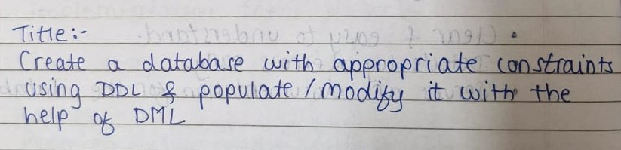
Description: In this assignment, we applied various SQL operations on two tables — Available_Equipments and Exercises — demonstrating both DML and DDL commands. For Available_Equipments, we created the table with a primary key, inserted ten records, updated and deleted specific entries, added and modified a column, dropped it, and renamed both a column and the table. For Exercises, which has a foreign key referencing Available_Equipments, we inserted ten linked exercise records, performed updates and deletions, added and modified a column, removed it, and renamed a column and the table. These steps covered key SQL functions for managing and modifying relational databases.

Screenshots/Output:

Availabale Equipments Table:
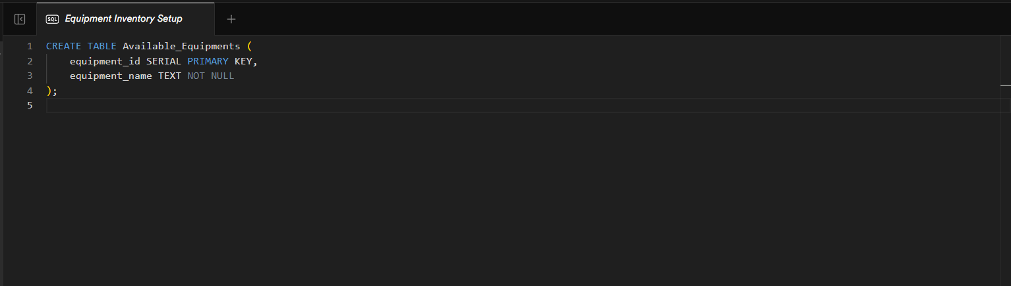
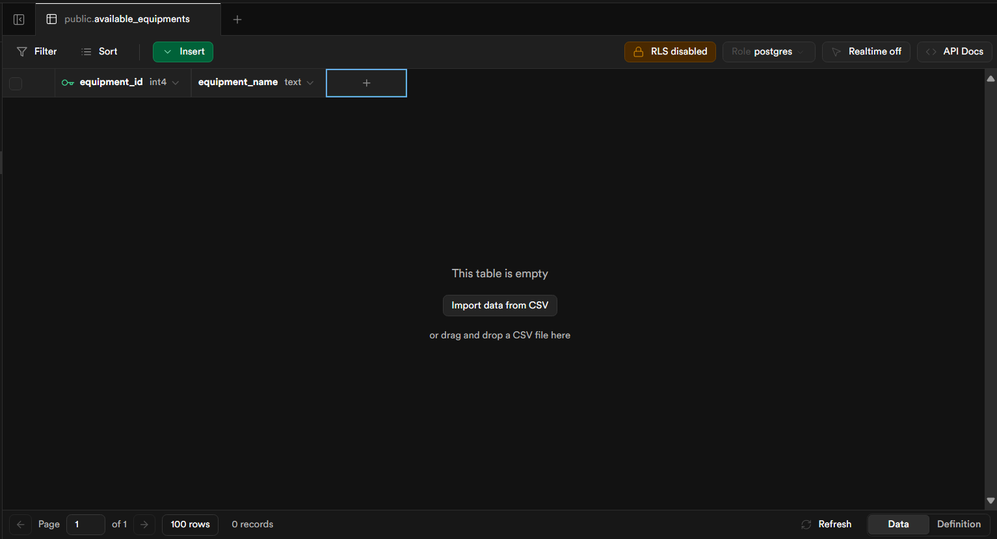
Table Creation
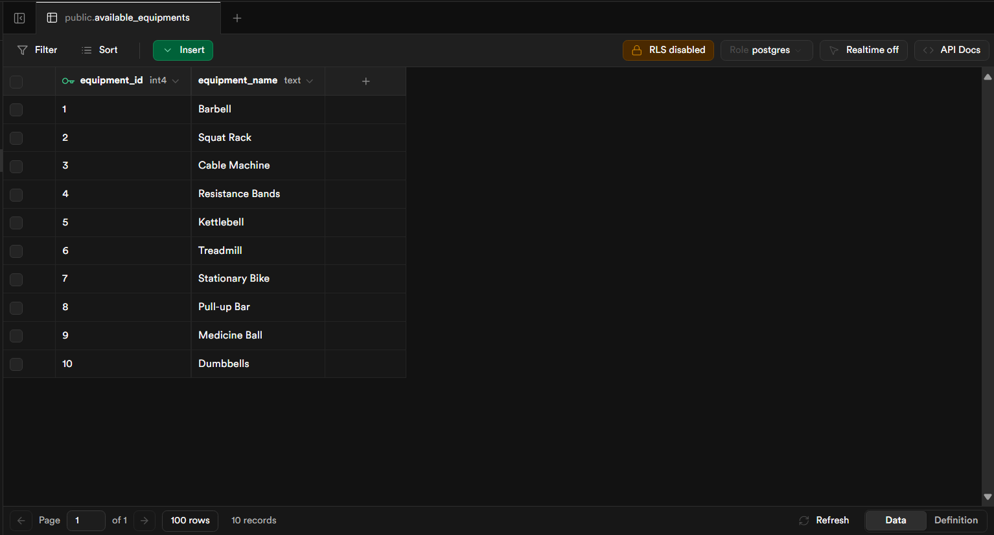
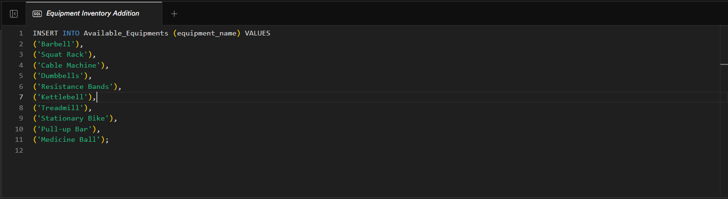
Insert 10 Rows

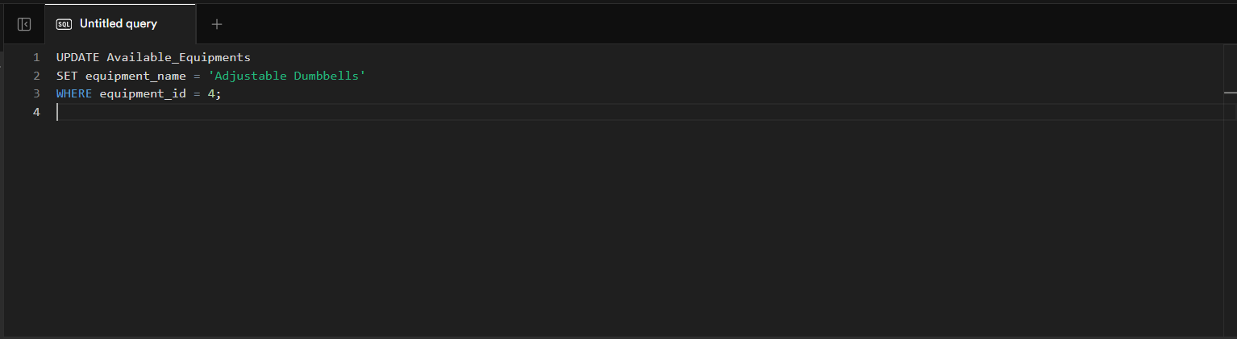
Update
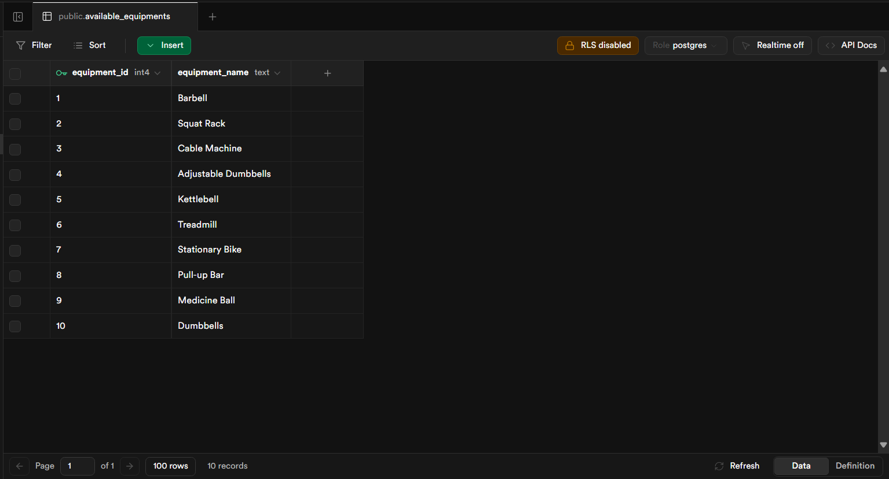

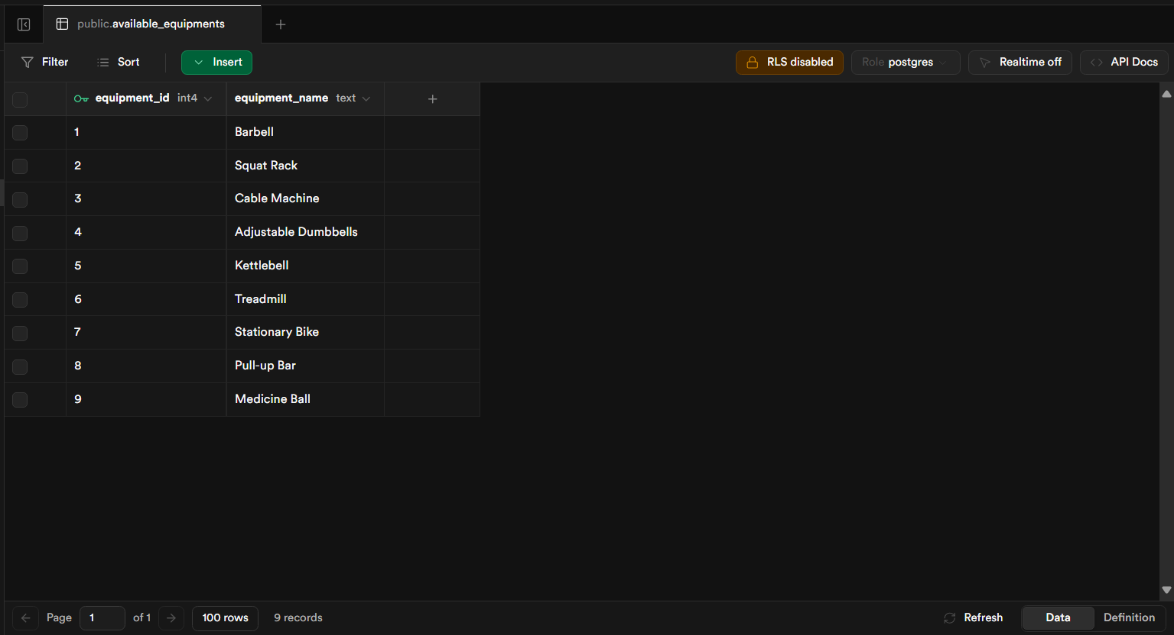
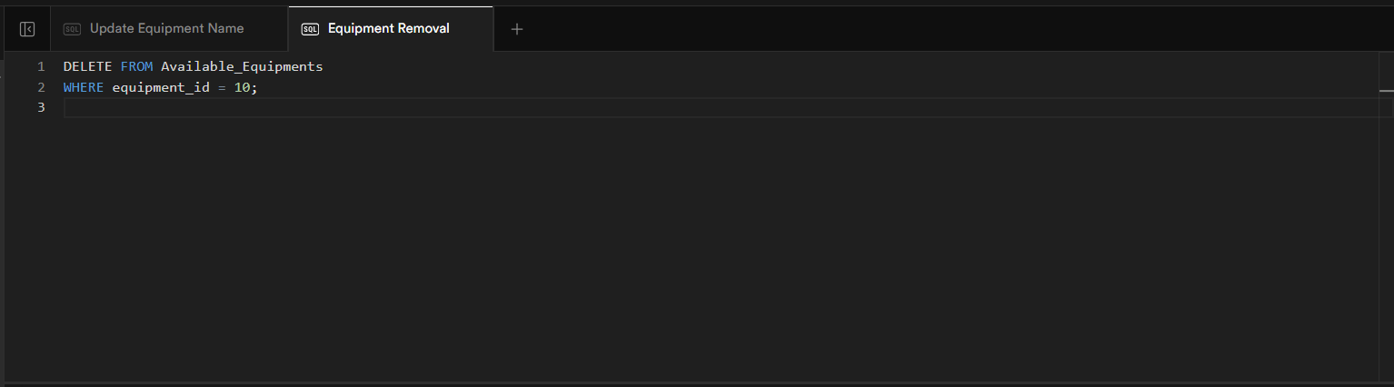
Delete
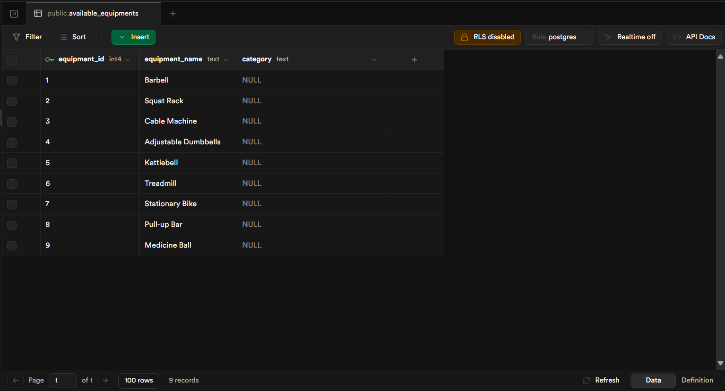
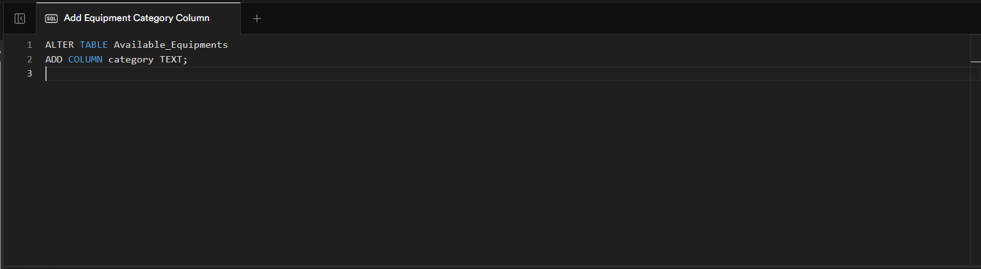
Add a column

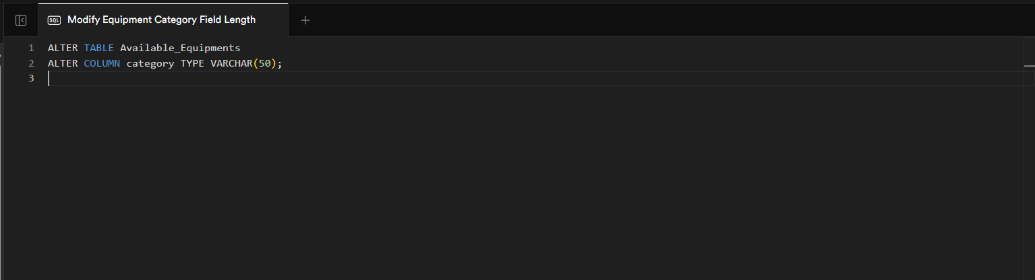
Modify column type

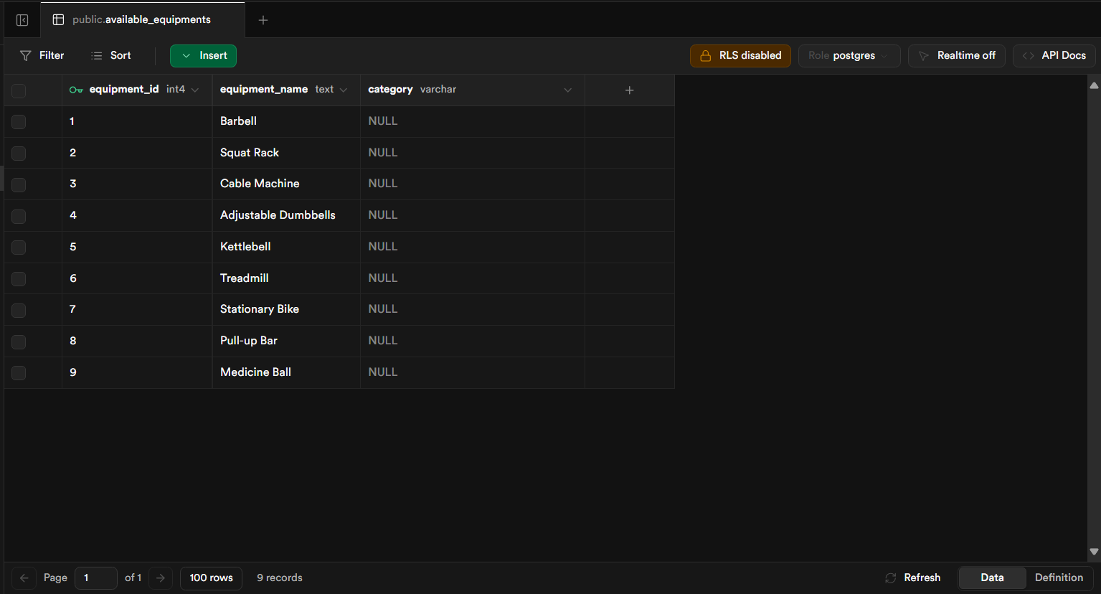
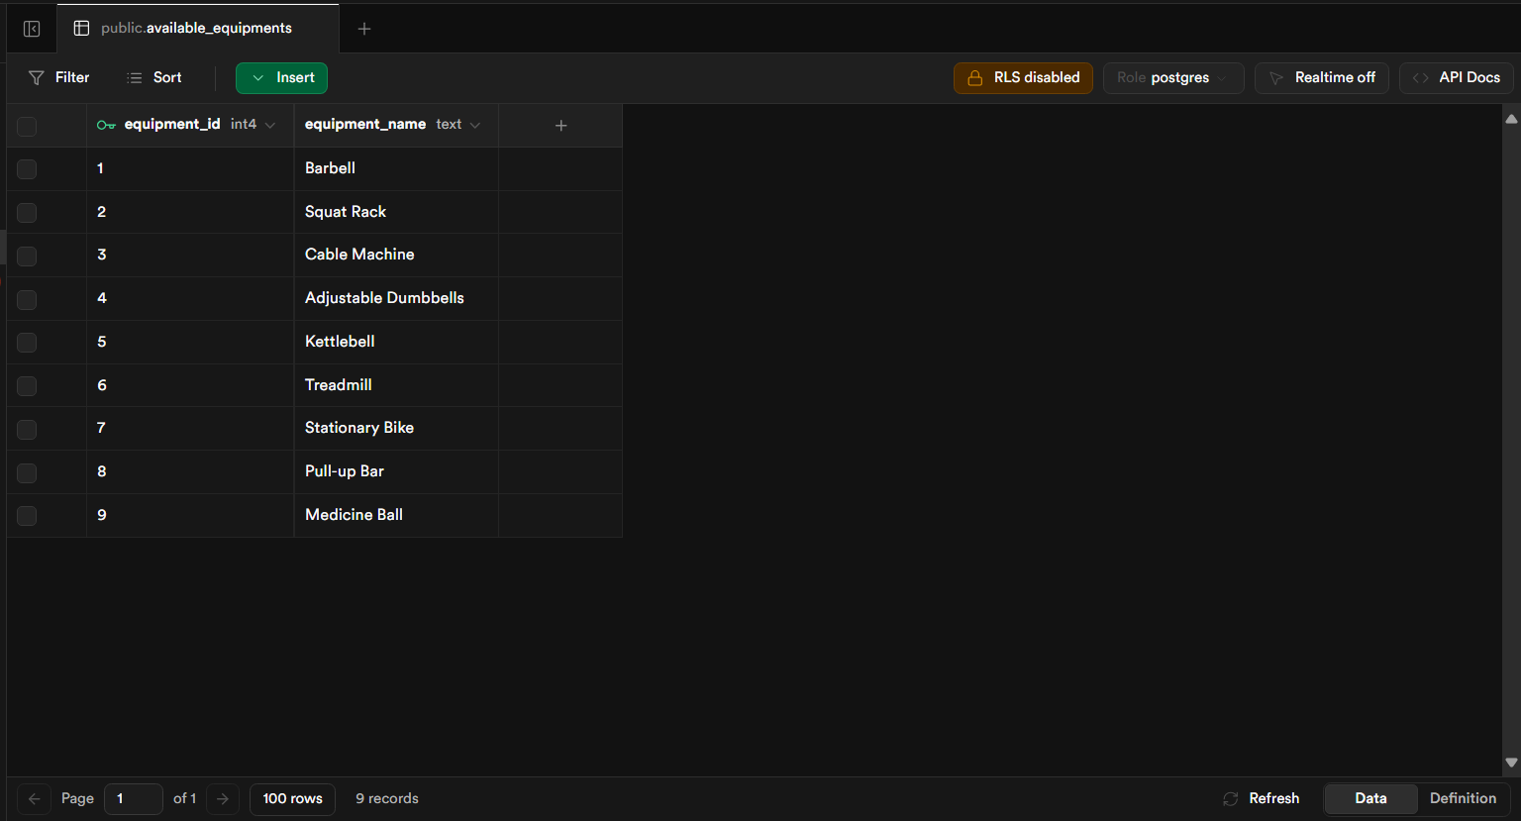
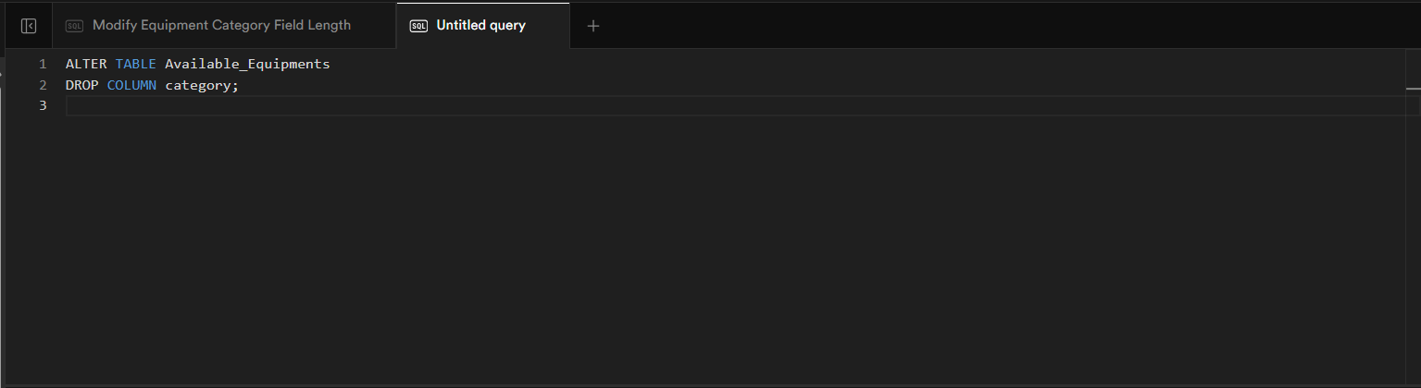
Drop a column
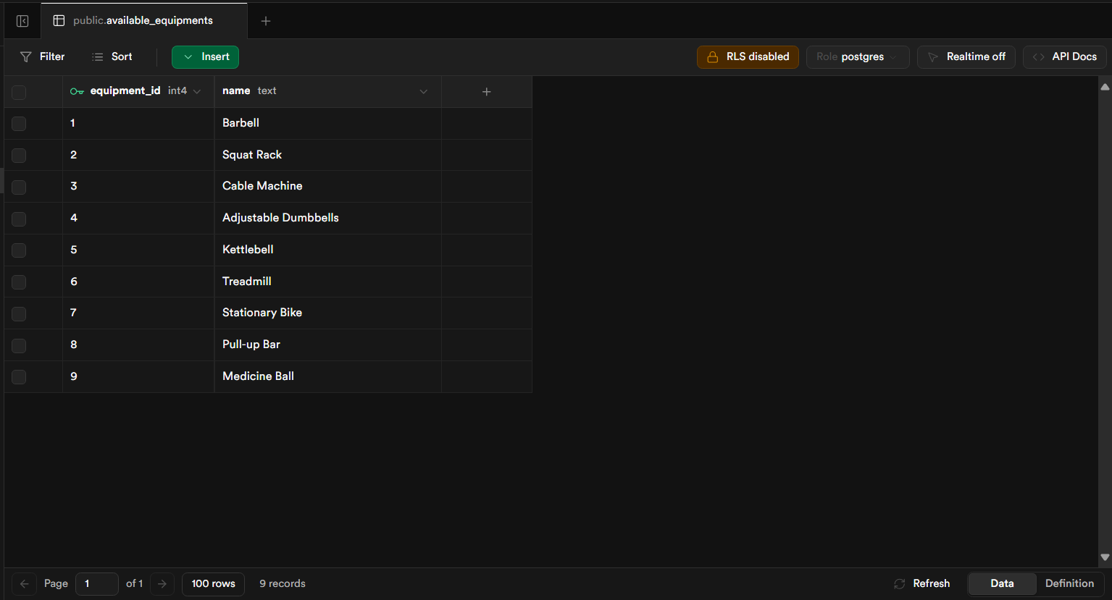
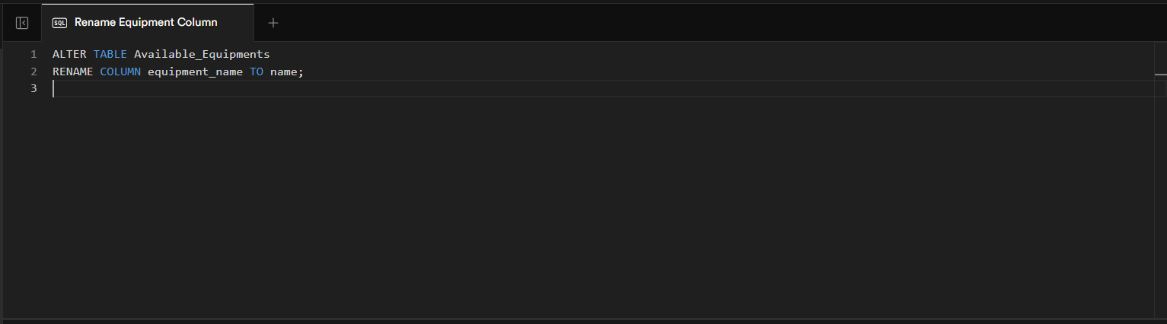
Rename Column

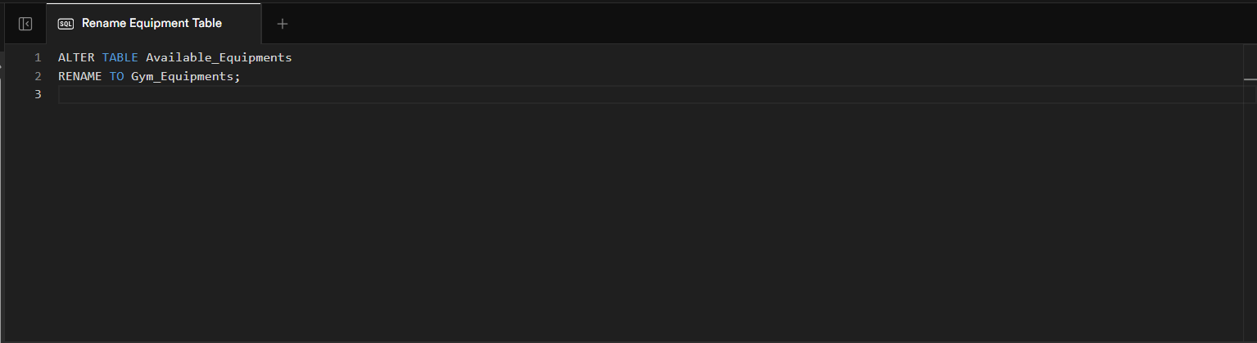
Rename Table
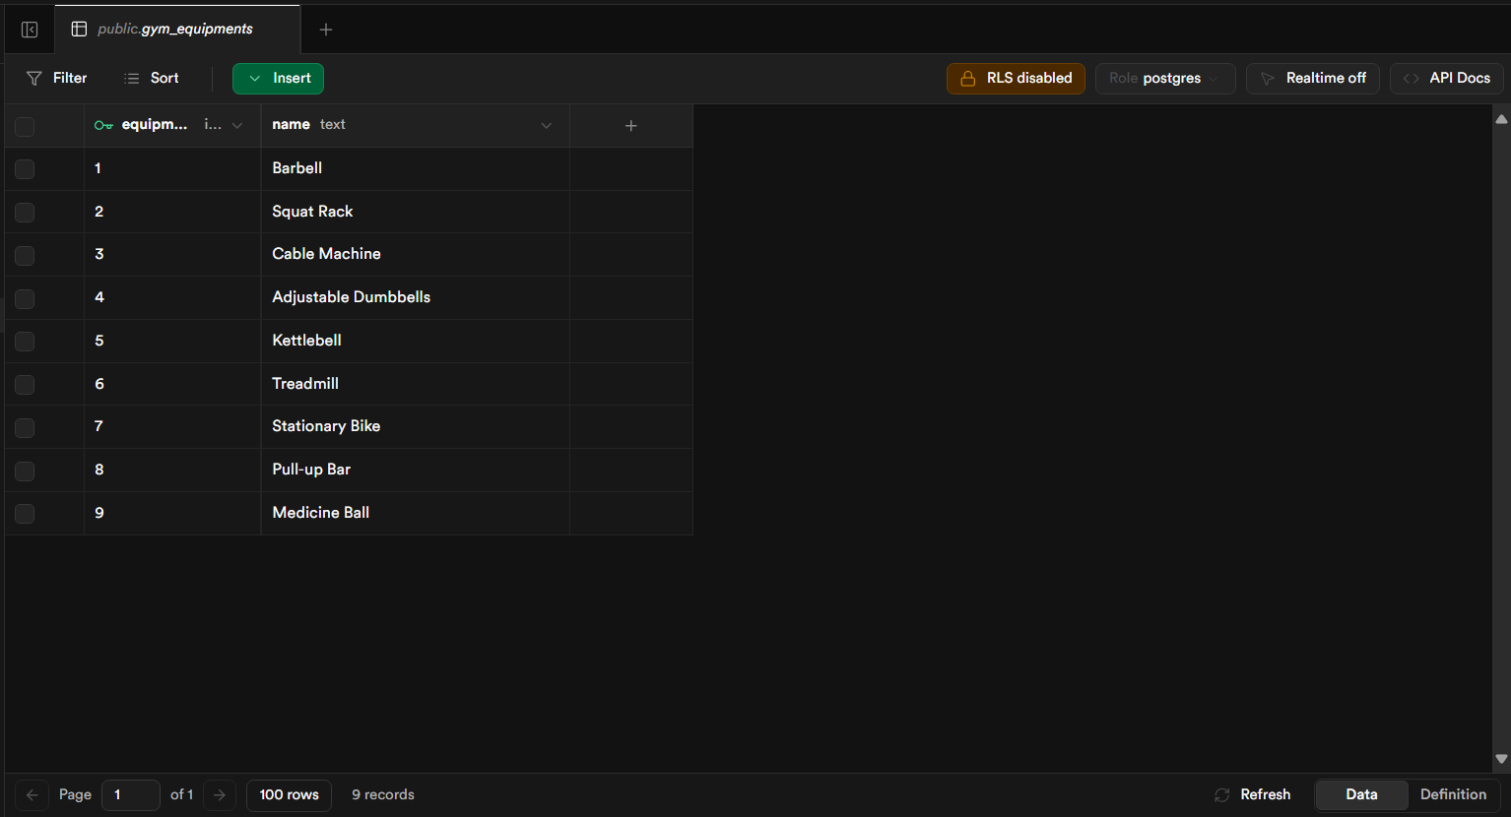

Exercises Table:
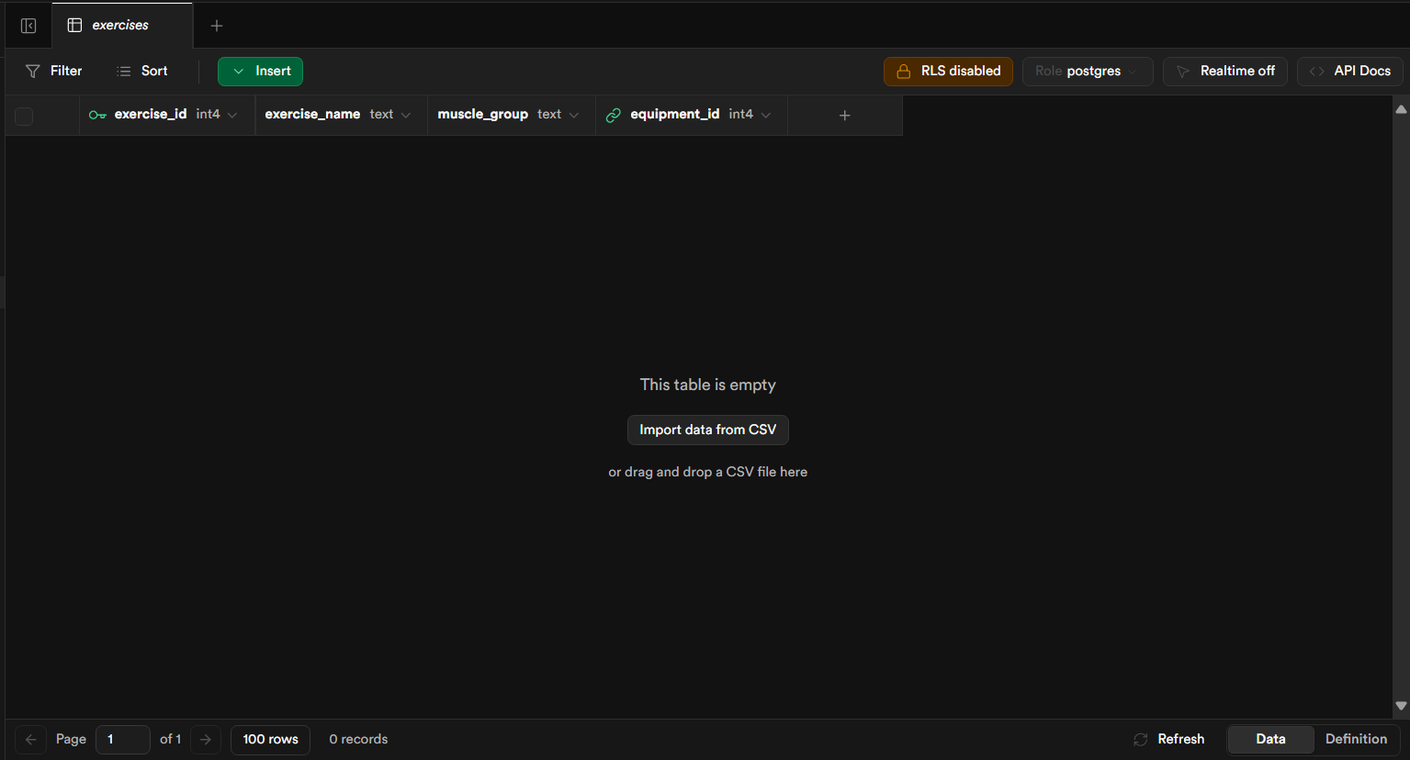
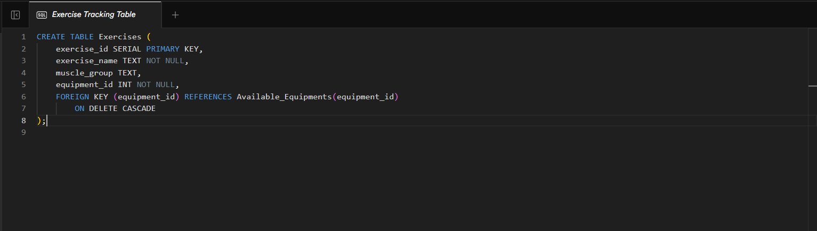
Table Creation

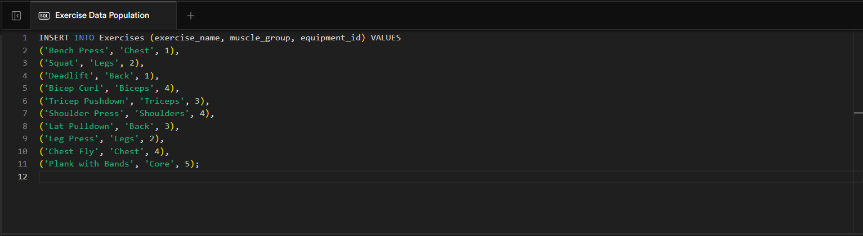
Insert 10 Rows

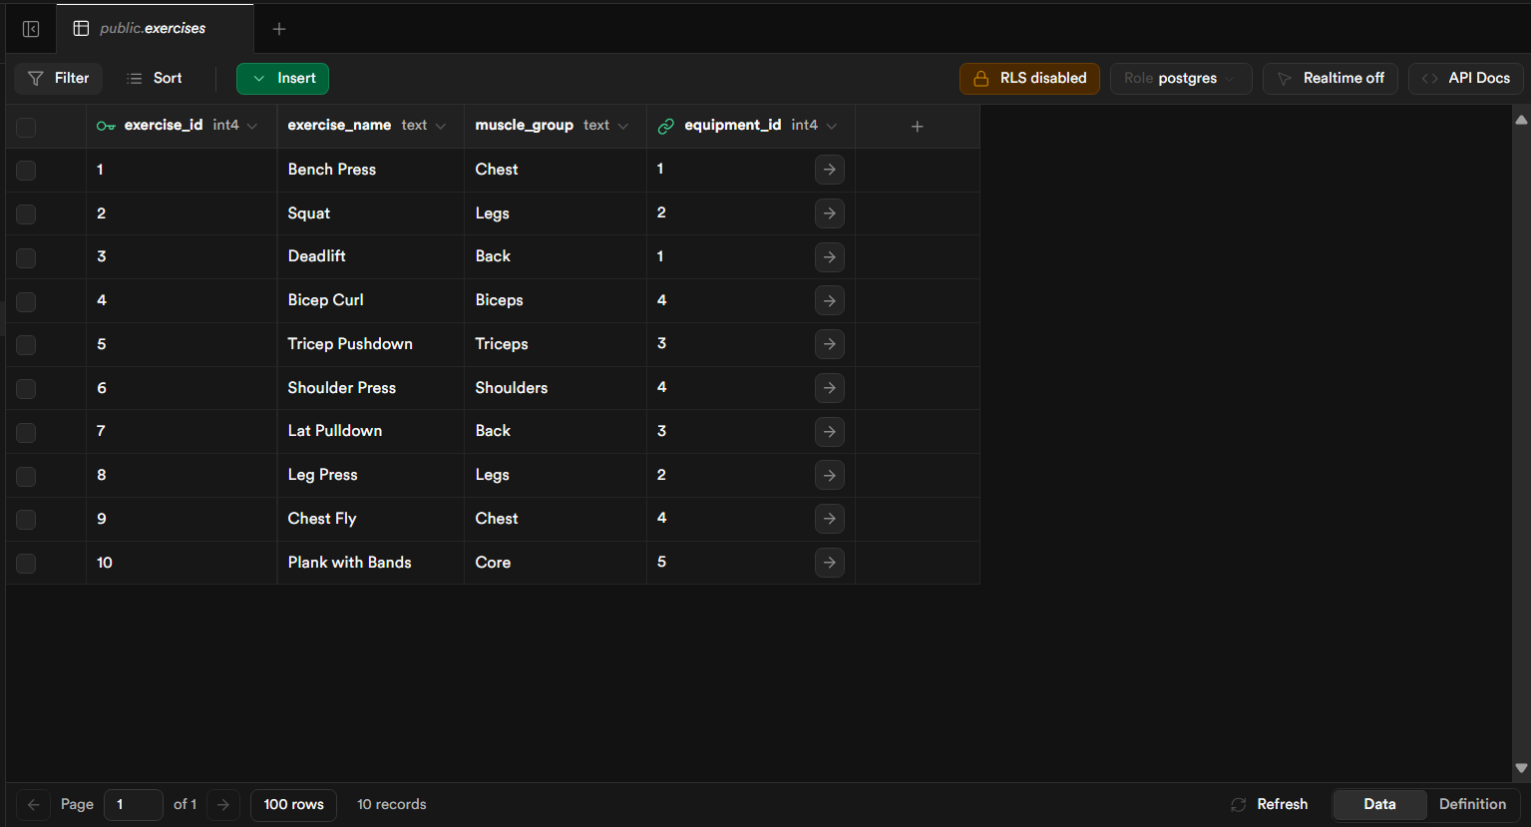
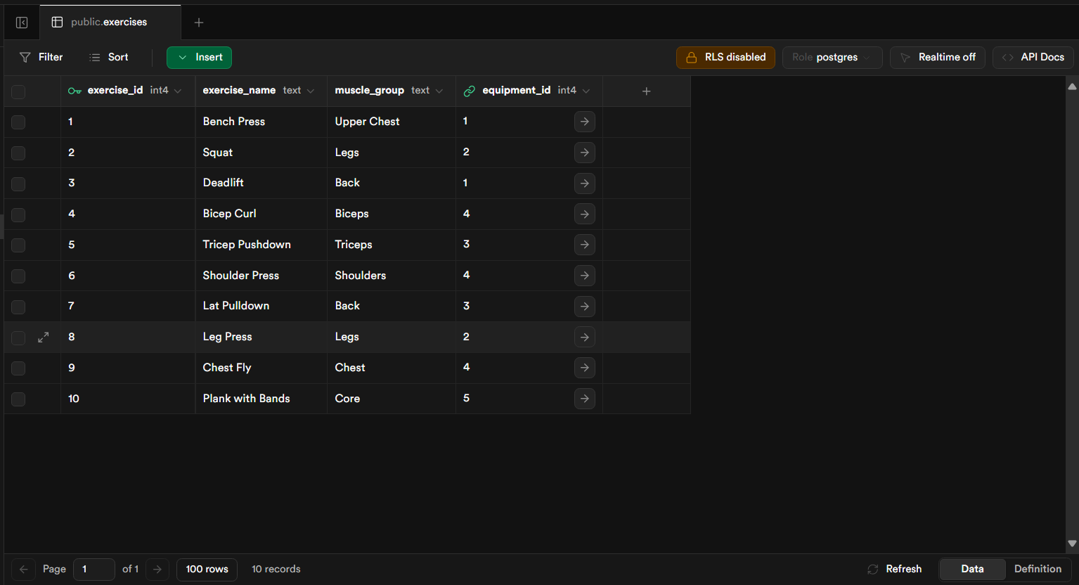
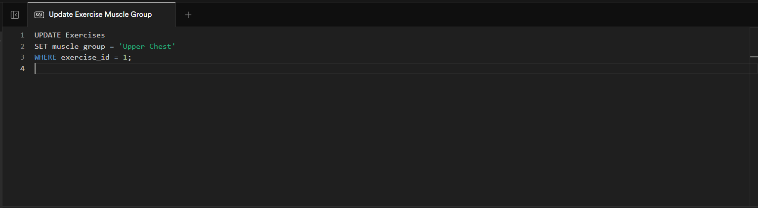
Update
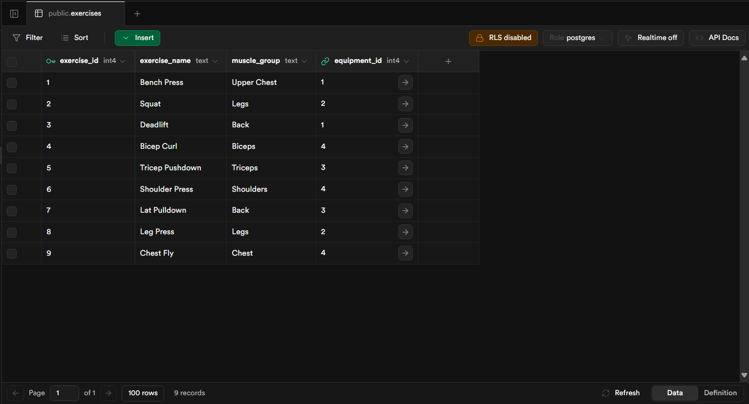
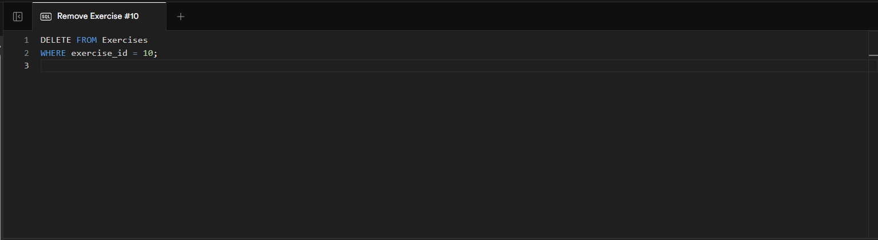
Delete

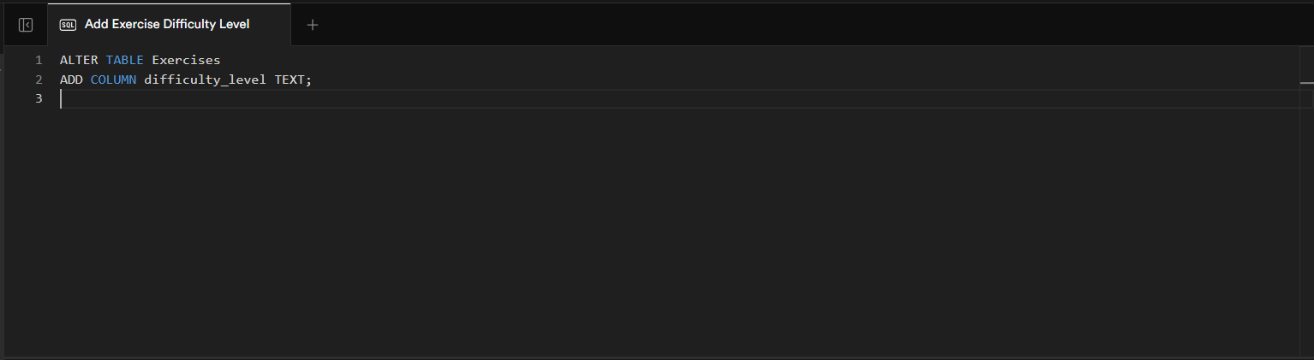
Add a column

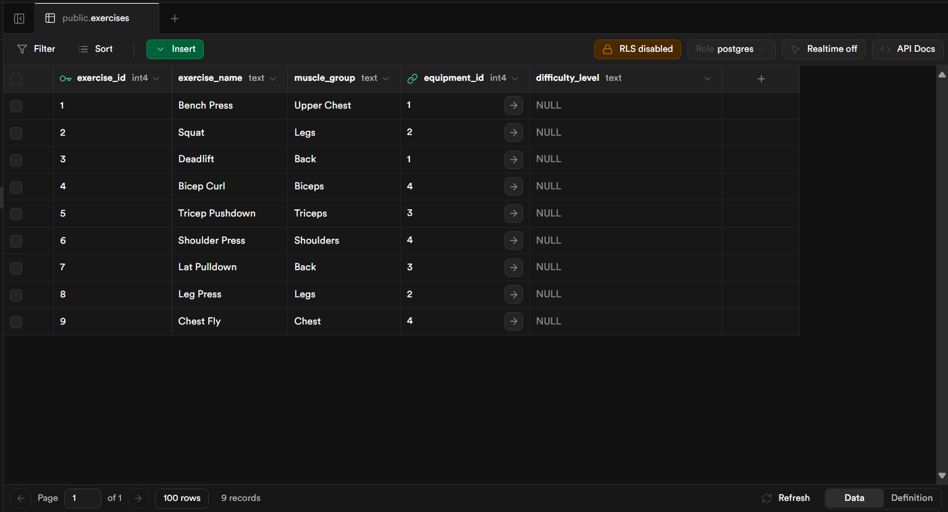

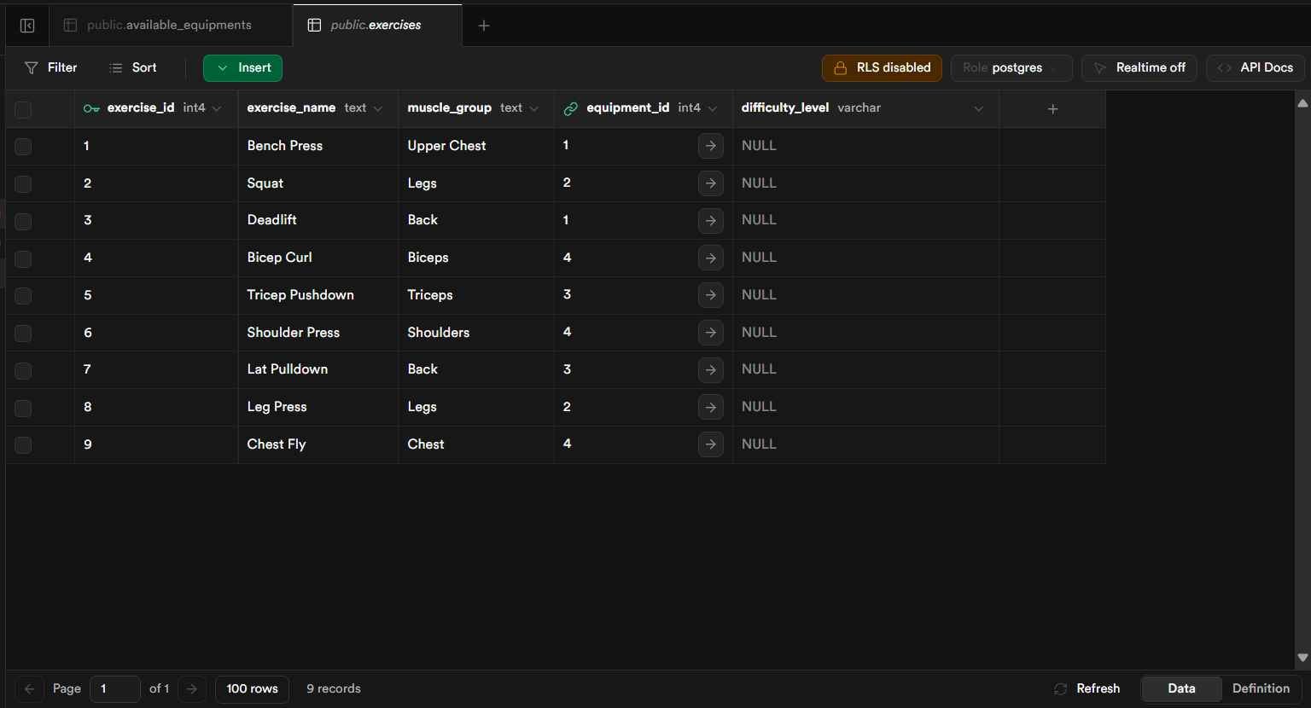
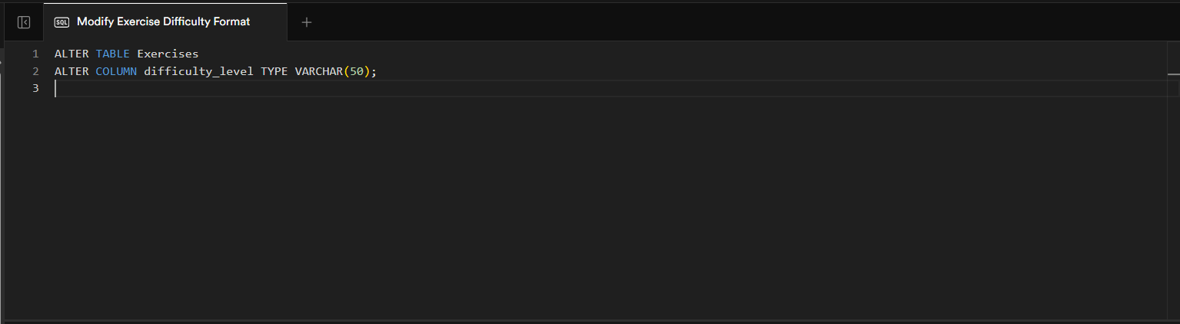
Modify column type
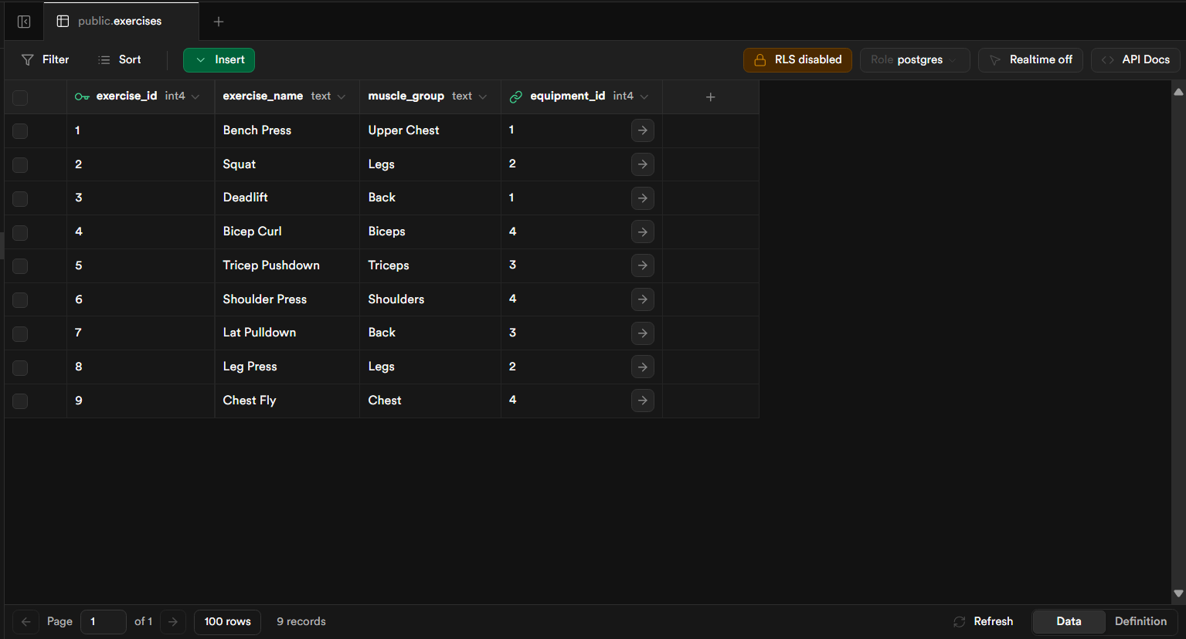
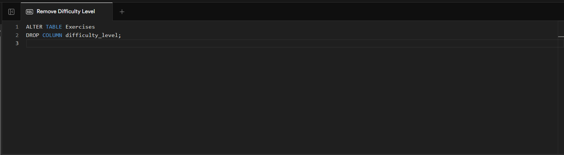
Drop a column

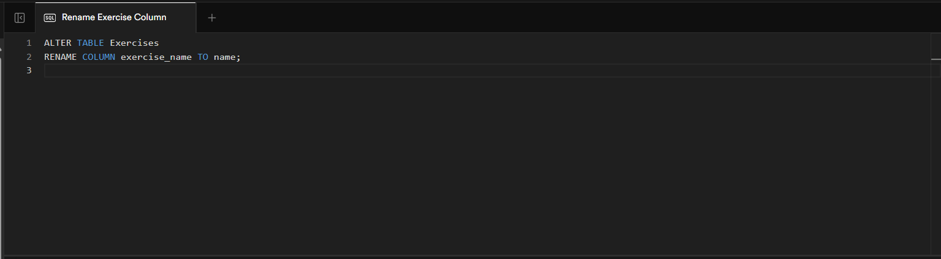
Rename Column

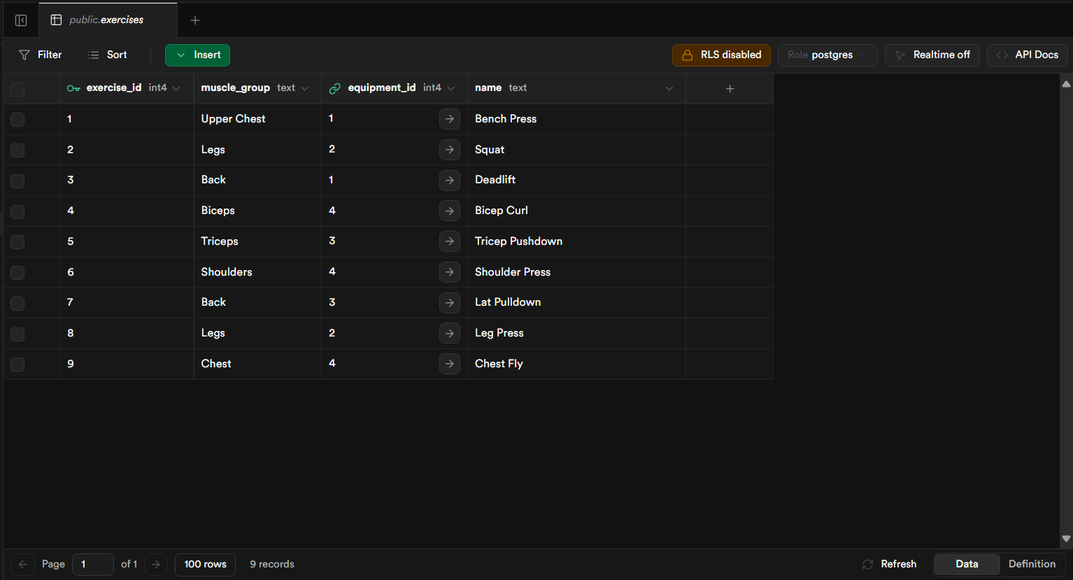
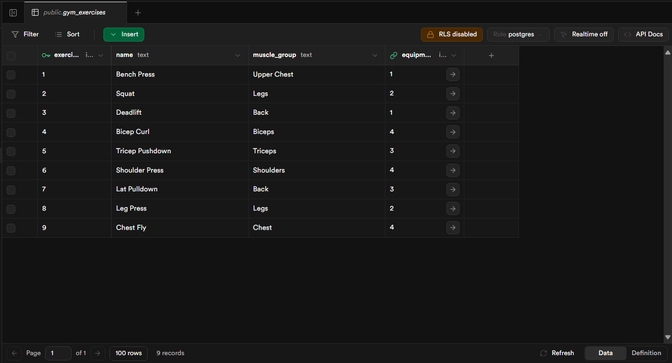
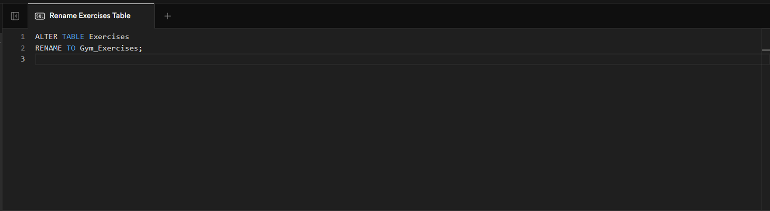
Rename Table

